Getting Back On The Straight and Narrow

A tip for straight hole patterns when using punch sets.

(insert punch0001.jpg)
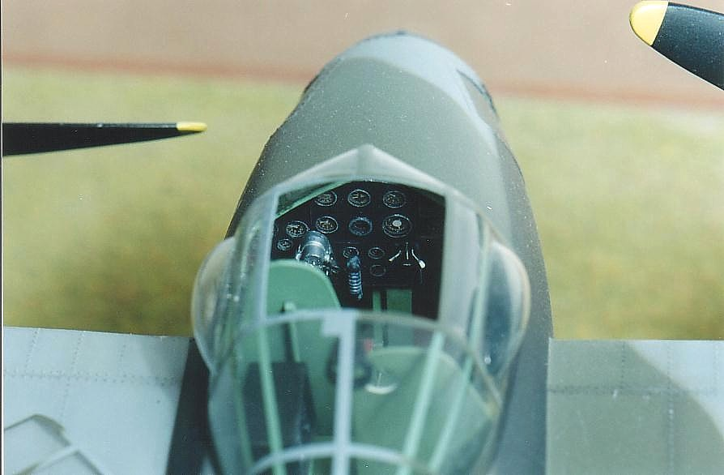
Instrument panel in 1/32 Mosquito done with aid of a punch set, using this technique.

PREAMBLE (or PRE-RAMBLE, as you wish)

This article deals with using punch sets as part of the process for fabricating instrument panels. For those who don’t own a punch set, I highly recommend their addition to this years Christmas gift list (I dropped many not so subtle hints, before my wife bought me mine for Christmas several years ago). The other obvious means for producing holes is using drills of course. I’ve found though, that on thin plastic (i.e. .010”-.020”) they tend to leave a burr which can be a pain to clean up, and larger diameter drills tend to “bind’ on thin plastic, and tear it. Punches leave a nice clean hole, with the added bonus that the slug can be put to use as access panel covers, fairings (i.e. faired over gun ports), dials and such. Now on to the gist of the article.
(Insert punch0002.jpg and punch 0003.jpg)
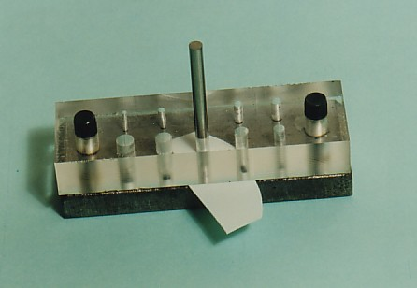

A typical punch set (upper die is clear)

PROBLEM

Now and then I’ve taken to making my own instrument panels using plastic card and Waldron (or other) bezels and instrument faces. The problem that I had was producing all of the holes in an instrument cluster so that they would all line up as they should. Even if a hole was mispositioned by .020” or .030” it really showed. Some of the holes were inevitably slightly off center or not spaced equally, even when I had laid out the hole pattern using scale (ruler) and pencil. The problem centered around (if you’ll excuse the pun) not being able to get the hole centerline on the layout, perfectly in the center of the hole in the upper/lower die of the punch set.

THE SOLUTION

One day while agonizing over another wavy hole pattern, a bright light shone through the window and it came to me. “The Band!!” Oh, sorry, that was another bright light. As for this particular bright light, here’s what I came up with.

I took my punches to work and had one of my friends in the tool room grind the non-punching end of each punch (this was the dull end on my set) to a conical shape (all done during his lunch hour I can assure you!!!!). Now I understand that those of you who work for the likes of Microsoft or Burger King are thinking, “I wonder where our company’s Tool Room is?” All is not lost. With a steady hand, I expect that anyone with a bench grinder or small lathe at home should be able to do this. Don’t forget your safety glasses though, and try not to accidentally grind a conical shape onto your index finger.

(insert punch0003.jpg)
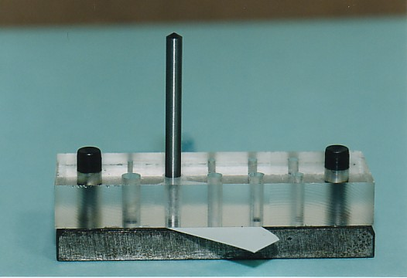

Modified punch with conical end

With your modified punches in hand, you can lay out your instrument cluster pattern on the plastic card with a sharp pencil and a scale (ruler). Giving the plastic a light sanding with some 600 grit paper makes it easier for the pencil to leave its mark. Now drill (I know I said drilling causes problems but bear with me) a hole at the centerline for each instrument hole. I usually use somewhere between a # 75 and # 80 drill. The idea of starting with the drill is that it’s much easier to accurately produce a pilot hole exactly on the centerline with a small drill.

Drill # 75 (.021”) - #80 (.014”)

Laying out a 6 hole instrument cluster pattern

Now slide your instrument panel in between the upper and lower dies and roughly eyeball the drilled hole in the center of the selected diameter die hole.

Note: this gap is for illustration purposes. The space between the dies should be just enough to insert the plastic card.
Lower Die
Upper Die
Instrument Panel
(Plastic card)
Drilled Hole

Place your punch with the conical side down, into the upper die until it contacts the instrument panel/plastic card. Manipulate the panel while keeping light pressure on the punch until you see/feel the point of the punch fall into the hole.
Upper Die
Lower Die
Plastic card
Punch

Finding the drilled hoe

Keeping pressure on the punch, jiggle the panel back and forth until the punch taper (conical section) fully seats into the drilled hole (i.e. panel no longer moves laterally). You’ve now found the exact center of the hole in the dies.

Upper Die
Lower Die
Plastic card
Punch

Punch taper fully seated

Remove the punch (being careful not to move the panel), turn it around, reinsert it in the upper die with the punching side down and punch out your hole. I use a small piece of soft aluminum or wood to strike the punch, that way I don’t deform the conical end of the punch.

I hope this little technique helps keep your punching activities “on the straight and narrow”.

