One the reasons for building this Revell-Monogram F-14 in the markings of VF-103, is all due to a photo. The photo in question was an F-14B of VF-103 flying high over a burning oil field. Wings fully swept back, engine exhaust nozzles closed, the upper surfaces of the plane totally covered in dirt and grease stains. The image of the plane looked absolutely menacing. If you have seen this image, then perhaps you know what I mean.

As previously stated, the kit in question is Revell-Monograms version of Grumman’s famous F-14. Overall there is not a whole lot to say about this kit, as it has all been said before. Suffice to say it is go kit at an affordable price.

I built this plane nearly out of the box. This kit is sold as an F-14D but I changed this to an F-14B. Although unseen the cockpit was modified to B standard. The D style pod under the nose was replace with one carried by an F-14B. This was scavenged from an Italeri F-14 kit. The closed exhaust nozzles and decals came from Hasegawa’s F-14B kit.

The plane was built with wings fully extended. To eliminate the gap that is created when the wings are ‘open’ I increased the bladder by using Tamiya putty and Evergreen plastic sheets (see image below). I used the bladder found in the Hasegawa kit as a template.
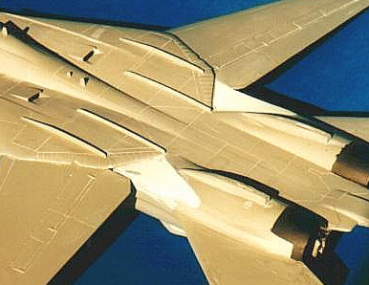

The exhaust area of the kit was sanded back to remove the curved shaped and was later re-scribed to give that ‘angular look’ associated with the B and D type Tomcats.

I used Tamiya flat black, Gunze Sangyo’s Dk.Ghost Gray and Lt.Ghost Gray for the model. After the standard colours were applied, I mixed various shades of gray to give the appearance of that worn out look associated with this aircraft. All colours were applied using a Lenco 301 airbrush which worked extremely well.

Once all colours were dry the plane was coated using Tamiya Clear. The decals were applied when everything was dry again. A few days later, a bit of a wash using water colours and some more spraying with the airbrush and whole plane would be ready for an application of Testor’s Dullcoat.

Overall I enjoyed building this F-14.

