
New Releases
1/48 Sukhoi Su-7 BKL:
New from Resin Art is a highly detailed interior set for the Kopro/Eduard Su-7 kit. Considerable research has gone into this multi-media set with the assistance of the Vyskov Air Museum. The set includes resin parts, pre-coloured & normal photo-etch details, plus a vac-from canopy. Extensive instructions accompany this package with superb quality graphics, extensive painting guides and colour cross references to four leading paint brands.
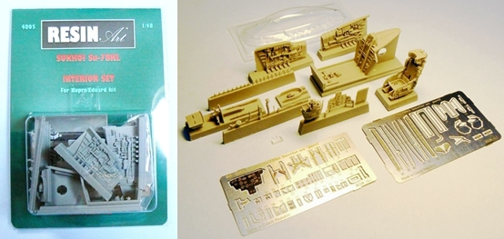

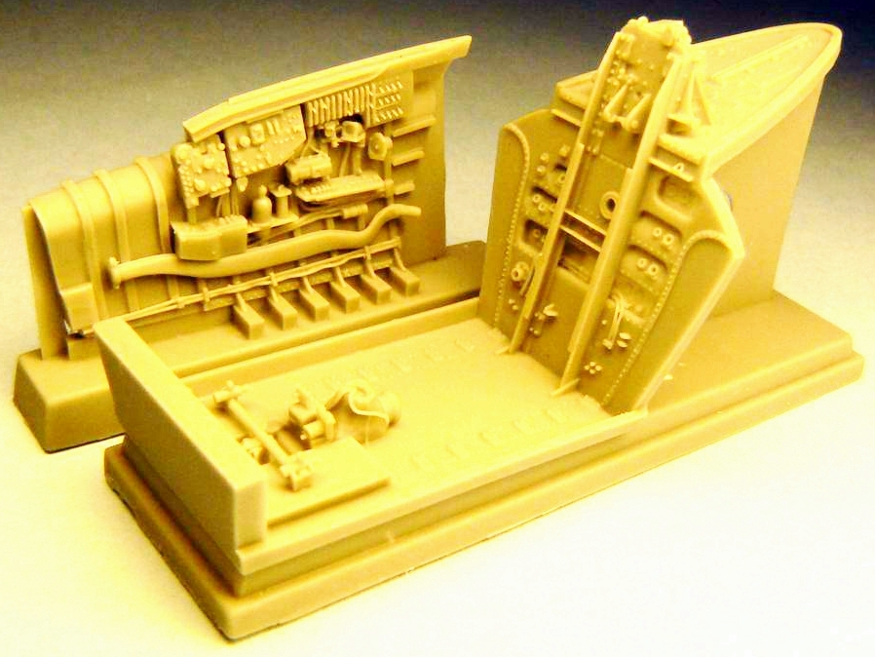
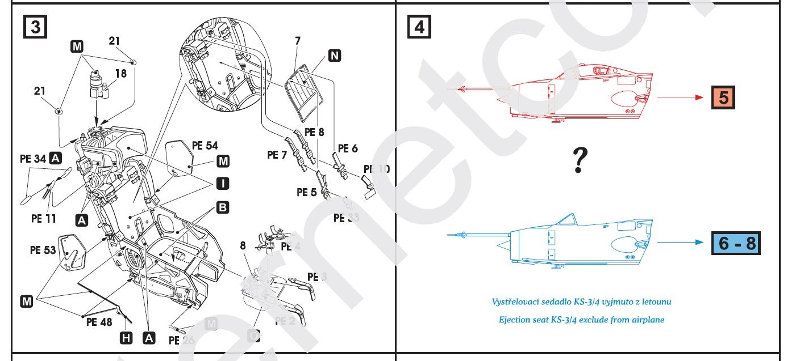

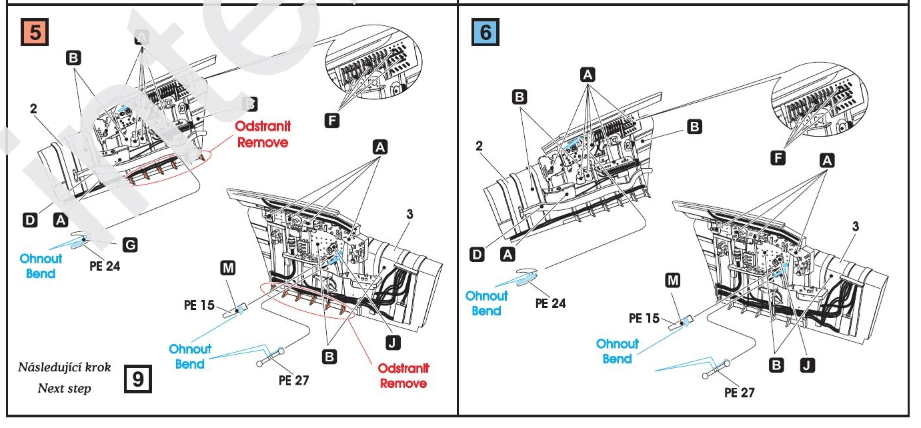


1/48 General Dynamics F-111:
From Resin Art’s “Simple” range are 1/48 wheels intended for the F-111A/C/G kit by Academy/Italeri. The accompanying pictures give an indication of detail levels:
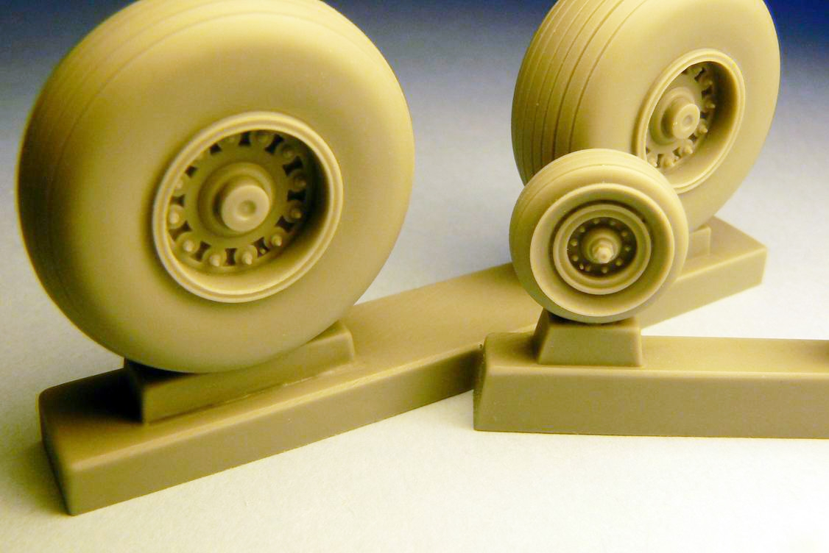
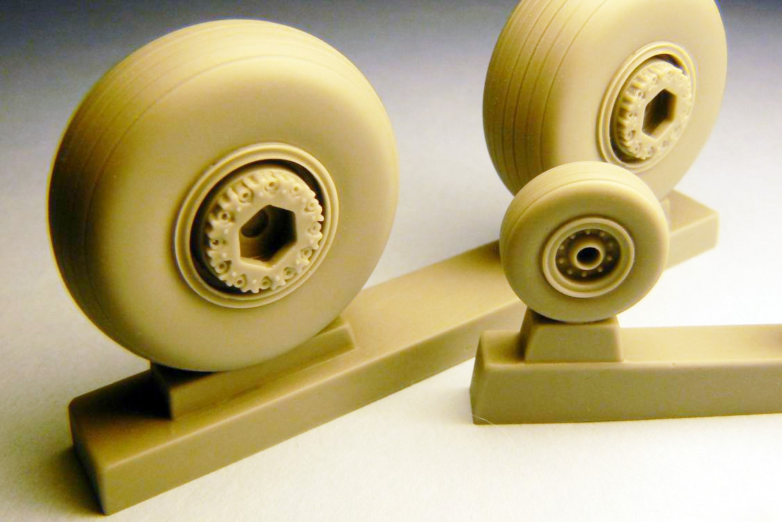
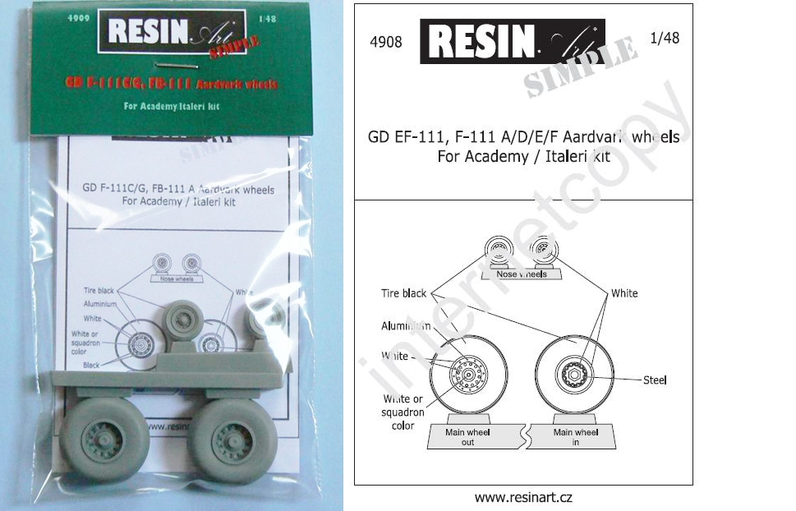

Both of the above sets will be with stockists very soon. For more information on Resin Art’s range and stockists please click here.

